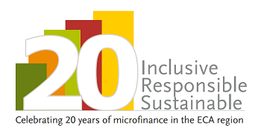
Call for nominations
(self-nominations are welcome)
for
2017 Financial Inclusion Ambassador Award
MFC is launching the third edition of the Ambassador Award for the MFC members and partners’ advocacy efforts towards financial inclusion. See 2016 and 2015 Ambassadors here: http://mfc.org.pl/ambassadors-contacts/
Share your tips for effective advocacy
This year we are seeking members (organizations and/or individuals), who significantly contributed to the successful process of promotion or advocacy for financial inclusion, at the country level or at the EU level. The nominated person engaged in a dialog that ended up with a significant advancement or helped address a major challenge, blockage or bottleneck.
If you have the relevant experience to share from the period of 2014 – up to now, or if you know MFC member (organization of individual), that should be nominated, please fill in the table below and send it to Ewa@mfc.org.pl latest by May 5th, 2017.
While reviewing the application, MFC team will look at:
- How collaborative was the process the applicant engaged in?
- What are the expected or actual results of the efforts undertaken by the applicant?
Please note the information you are sharing will stay confidential unless you agree to publish all or selected information.
Name of nominated organization / person
www
Contact person name
Email and phone number of contact person
Tell us about your advocacy efforts:
Please describe the people you met between 2014 and now (positions and institutions they represented), the purpose of the meetings and their regularity, other partners that were engaged, as well as the expected or achieved results.

Name of the nominating person, organization and contact information (not relevant in case of self-nomination)

This initiative has received financial support from the European Union Programme for Employment and Social Innovation "EaSI" (2014-2020). For further information please consult: http://ec.europa.eu/social/easi

